LAB ASSIGMENT-3
1.Create table EMPLOYEE with the following details.
FIELD NAME | TYPE
EMPLOYEE_ID | NUMBER(6)
LAST_NAME | VARCHAR2(25)
JOB_ID | VARCHAR2(10)
SALARY | NUMBER(8,2)
COMM_PCT | NUMBER (4,2)
MGR_ID | NUMBER (6)
DEPARTMENT_ID | NUMBER (4)

SQL QUERY:
CREATE TABLE OFFICE_EMP (
EMPLOYEE_ID NUMBER(6),
LAST_NAME VARCHAR2(25),
JOB_ID VARCHAR2(10),
SALARY NUMBER(8,2),
COMM_PCT NUMBER(4,2),
MGR_ID NUMBER(6),
DEPARTMENT_ID NUMBER(4)
);

EXPECTED OUTPUT:
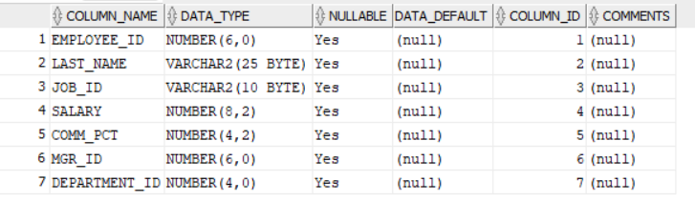

2. Insert the following data into EMPLOYEE table.
EMPLOYEE_ID | LAST_NAME | JOB_ID | SALARY | COMM_PCT | MGR_ID | DEPARTMENT_ID
198 | Connell | SH_CLERK | 2600 | 2.5 | 124 | 50
199 | Grant | SH_CLERK | 2600 | 2.2 | 124 | 50
200 | Whalen | AD_ASST | 4400 | 1.3 | 101 | 10
201 | Hartstein | IT_PROG | 6000 | null | 100 | 20
202 | Fay | AC_MGR | 6500 | null | 210 | 20
203 | Mavris | AD_VP | 7500 | null | 101 | 40
204 | Baer | AD_PRES | 3500 | 1.5 | 101 | 90
205 | Higgins | AC_MGR | 2300 | null | 101 | 60
206 | Gitz | IT_PROG | 5000 | null | 103 | 60
100 | King | AD_ASST | 8956 | 0.3 | 108 | 100
101 | Kochar | SH_CLERK | 3400 | 1.3 | 118 | 30

SQL QUERY:
INSERT ALL
INTO OFFICE_EMP VALUES(198,'Connell', 'SH_CLERK', 2600,2.5,124,50)
INTO OFFICE_EMP VALUES(199,'Grant', 'SH_CLERK',2600,2.2,124,50)
INTO OFFICE_EMP VALUES(200,'whalen', 'AD_ASST',4400,1.3,101,10)
INTO OFFICE_EMP VALUES(201,'Hartstein','IT_PROG',6000,NULL,100,20)
INTO OFFICE_EMP VALUES(202,'Fay', 'AC_MGR', 6500,NULL,210,20)
INTO OFFICE_EMP VALUES(203,'Mavris', 'AD_VP',7500,NULL,101,40)
INTO OFFICE_EMP VALUES(204,'Baer', 'AD_PRES',3500,1.5,101,90)
INTO OFFICE_EMP VALUES(205,'HIggis','AC_MGR',2300,NULL,101,60)
INTO OFFICE_EMP VALUES(206,'Gitz','IT_PROG',5000,NULL,103,60)
INTO OFFICE_EMP VALUES(100,'King','AD_ASST',8956,0.3,108,100)
INTO OFFICE_EMP VALUES(101,'Kochar','SH_CLERK',3400,1.3,118,30)
SELECT * FROM DUAL;
COMMIT;

EXPECTED OUTPUT: 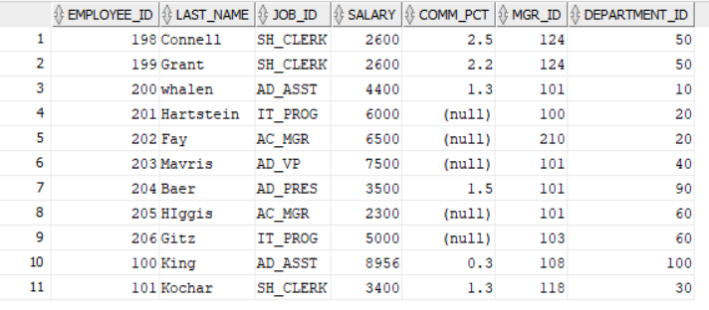
3. Display last_name, job_id, employee_id for each employee with employee_id appearing first.
SQL QUERY:
SELECT LAST_NAME, JOB_ID, EMPLOYEE_ID FROM OFFICE_EMP;
EXPECTED OUTPUT:
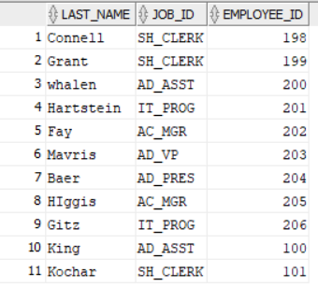
4. Display the details of all employees of department 60.
SQL OUERY:
SELECT * FROM OFFICE_EMP WHERE DEPARTMENT_ID = 60; EXPECTED OUTPUT:
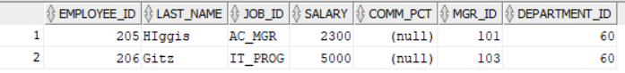
5. Display the employee details of the employee whose last_name is King.
SQL QUERY:
SELECT * FROM OFFICE_EMP WHERE LAST_NAME ='King';
EXPECTED OUTPUT:
6. Display unique job_id from EMPLOYEE table. Give alias name to the column as JOB_TITLE.
SQL QUERY:
SELECT DISTINCT JOB_ID AS JOB_TITLE FROM OFFICE_EMP;
EXPECTED OUTPUT:
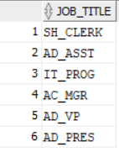
7. Display last_name, salary and salary increase of Rs300. Give the new column name as ‘Increased Salary’.
SQL QUERY:
SELECT LAST_NAME,SALARY,(SALARY+300) AS INCREASED_SALARY FROM OFFICE_EMP;
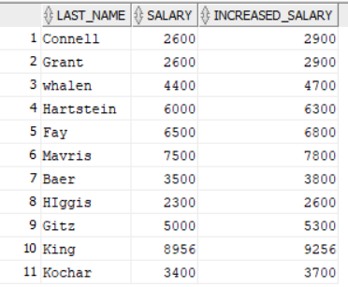
EXPECTED OUTPUT :

8. Display last_name, salary and annual compensation of all employees, plus a onetime bonus of Rs 100. Give an alias name to the column displaying annual compensation.
SQL QUERY:
SELECT LAST_NAME,SALARY, (SALARY*12)+100 AS "ANNUAL COMPENSATION" FROM OFFICE_EMP;
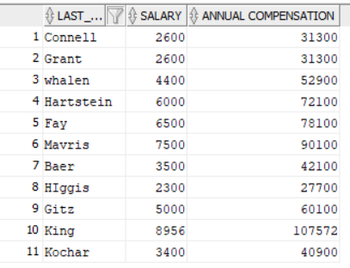
EXPECTED OUTPUT:

9. Display the details of those employees who get commission.
SQL QUERY:
SELECT * FROM OFFICE_EMP WHERE COMM_PCT IS NOT NULL;
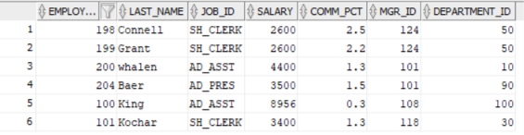
EXPECTED OUTPUT:

10. Display the details of those employees who do not get commission.
SQL QUERY:
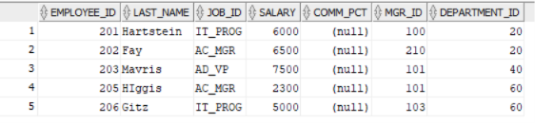
SELECT * FROM OFFICE_EMP WHERE COMM_PCT IS NULL;
EXPECTED OUTPUT:
11. Display the Employee_id, Department_id and Salary all employees whose salary is greater than 5000.
SQL QUERY:
SELECT EMPLOYEE_ID,DEPARTMENT_ID,SALARY FROM OFFICE_EMP WHERE SALARY > 5000;
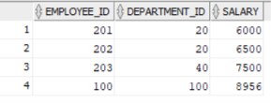
EXPECTED OUTPUT:

12. Display the Last_Name and Salary of all employees whose salary is between 4000 and 7000.
SQL QUERY:
SELECT LAST_NAME,SALARY FROM OFFICE_EMP WHERE SALARY BETWEEN 4000 AND 7000;
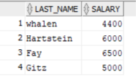
EXPECTED OUTPUT:

13. Display the details of all employees whose salary is either 6000 or 6500 or 7000.
SQL QUERY:
SELECT * FROM OFFICE_EMP WHERE SALARY IN(6000,6500,7000);
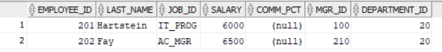
EXPECTED OUTPUT:

14.Display the details of all those employees who work either in department 10 or 20 or 30 or 50.
SQL QUERY:
SELECT * FROM OFFICE_EMP WHERE DEPARTMENT_ID IN (10,20,30,50);
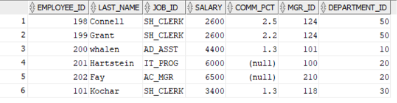
EXPECTED OUTPUT:

15. Display the details of all employees whose salary is not equal to 5000.
SQL QUERY:
SELECT * FROM OFFICE_EMP WHERE SALARY !=5000;
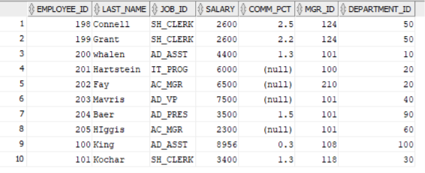
EXPECTED OUTPUT:

16. Display the details of all the CLERKS working in the organization.
SQL QUERY:
SELECT * FROM OFFICE_EMP WHERE JOB_ID LIKE '%CLERK%';
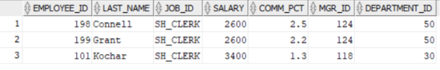
EXPECTED OUPUT:

17. Update the job_id’s of the employees who earn more than 5000 to Grade_A. Display the table EMPLOYEE after updating.
SQL QUERY:
UPDATE OFFICE_EMP SET JOB_ID = 'GRADE_A' WHERE SALARY >5000;
COMMIT;
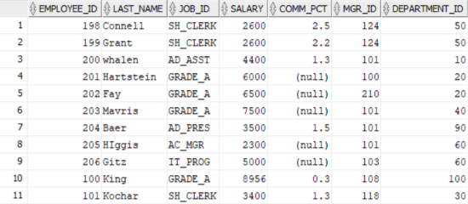
EXPECTED OUTPUT: 4 ROWS UPDATED

18. Display the details of all those employees who are either CLERK or PROGRAMMER or ASSISTANT.
SQL QUERY:
SELECT * FROM OFFICE_EMP
WHERE JOB_ID LIKE '%CLERK%'
OR JOB_ID LIKE '%PROG%'
OR JOB_ID LIKE '%ASST%';
EXPECTED OUTPUT:
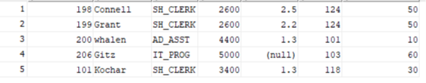

19. Display those employees from the EMPLOYEE table whose designation is CLERK and salary is less than 3000.
SQL QUERY:
SELECT * FROM OFFICE_EMP
WHERE JOB_ID LIKE '%CLERK%'
AND SALARY < 3000;
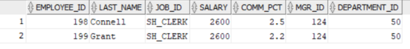
EXPECTED OUTPUT:

20. Display those employees Last_Name, Mgr_id from the EMPLOYEE table whose salary is above 3000 and work under Manager 101.
SQL QUERY:
SELECT LAST_NAME , MGR_ID FROM OFFICE_EMP
WHERE SALARY > 3000
AND MGR_ID = 101;
EXPECTED OUTPUT:


